Pupil premium strategy statement
Charlton-on-Otmoor CE Primary School
This statement details our school’s use of pupil premium (and recovery premium) funding to help improve the attainment of our disadvantaged pupils.
It outlines our pupil premium strategy, how we intend to spend the funding in this academic year and the outcomes for disadvantaged pupils last academic year.

School overview
Detail | Data
Number of pupils in school | 80 (plus 3 Nursery children)
Proportion (%) of pupil premium eligible pupils | 9% (7 children)  1% EY PP
Academic year that our current pupil premium strategy plan covers | 2023 to 2024
Date this statement was published | October 2023
Date on which it will be reviewed | July 2024
Statement authorised by | Governing Board
Pupil premium lead | Zoe Wells
Governor / Trustee lead | Emma Goulart

Funding overview
Detail | Amount
Pupil premium funding allocation this academic year | £14,170
Recovery premium funding allocation this academic year | N/A
Pupil premium (and recovery premium*) funding carried forward from previous years (enter £0 if not applicable)  *Recovery premium received in academic year 2021 to 2022 can be carried forward to academic year 2022 to 2023. Recovery premium received in academic year 2022 to 2023 cannot be carried forward to 2023 to 2024. | £0
Total budget for this academic year  If your school is an academy in a trust that pools this funding, state the amount available to your school this academic year | £14,170

Part A: Pupil premium strategy plan

Statement of intent
At Charlton on Otmoor Primary, we have high aspirations for our children, and we believe that no child should be left behind. We are determined to ensure that all our children are given every chance to realise their full potential. Through careful monitoring and reviewing of PP children’s progress and through communication with parents, we look to adapt the provision to match the needs of each PP child.

Through targeted academic support, our aim at Charlton is for pupils to:
- make accelerated progress
- receive high quality learning
- have access to additional support in lessons when needed
- be provided with more personalised learning and support
- develop SEMH skills.

Through high quality teaching, pupils at Charlton will:
- Experience a broad and balanced curriculum
- Develop cultural awareness and a greater awareness of the world they live in.

Our aim at Charlton is to use wider strategies to support pupils and families in relation to non-academic challenges to ensure that their pupils thrive at school. We will aim to:
- support families with access to extra curricular provision
- Provide uniform to families
- Enable children to access all educational visits

Challenges
This details the key challenges to achievement that we have identified among our disadvantaged pupils.
Challenge number | Detail of challenge
1 | Social, emotional and mental health difficulties.  Pupils in receipt of disadvantaged funding are likely to become passive or reluctant learners
2 | Limited access to wider opportunities and educational experiences through trips, visits, wrap around care.  children in receipt of PP are less likely to participate in reading, trips, visits or other enrichment activities.
3 | Gaps in reading, writing, maths and phonics.  In 2022-23 there was a much higher percentage of children in receipt of PP funding that are ‘well below’ in reading, writing and maths compared to those not in receipt of PP funding. Our aim is to move these children from ‘well below’ to ‘just below’ or ‘expected’.  Some of our children in receipt of PP are also on the SEN register which adds complexity to their progress, in some areas.
4 | Poor attendance and punctuality

Intended outcomes
This explains the outcomes we are aiming for by the end of our current strategy plan, and how we will measure whether they have been achieved.
Intended outcome | Success criteria
Increase the number of disadvantaged pupils achieving ‘high standard’ at KS2.  Improved rates of progress across school curriculum, especially in maths, reading and writing. | Progress of disadvantaged children is in line with non PP pupils. Measured through termly teacher assessment on insight, writing moderation.  Pupils will make accelerated progress in identified areas of need. This is through group support, 1:1 support and interventions. Children will be moved from ‘well below’ to ‘just below’ or ‘expected’.  In school tracking data (Insight) and end of Key Stage (GLD, KS1 and KS2, Multiplication check, Phonics Check) assessments will show an increase in the number of children working at age related expectation year on year and an increase in the number of disadvantaged pupils achieving the higher standard at the end of KS2.
Quality first teaching is embedded in practice of teachers and teaching assistants. Providing pupils with modelling/scaffolding/appropriate steps to achieve. | Pupils will make accelerated progress  Gaps in children’s learning will be identified and addressed quicker  Teachers and teaching assistants will have a wider range of strategies to support pupil(s) with additional needs.
Improved wellbeing for all pupils in our school, particularly our disadvantaged pupil | Identifying children who need support with their SEMH needs helps them to become more ready and able to learn. In turn, the children will be able to make good academic progress.  Observations of children’s engagement in learning.
Improved cultural and childhood experience for all pupils across school | Opportunities as cultural capital experiences (visits and visitors included) are planned and embedded in our curriculum, and these are accessed by all pupil premium children.
Improved cultural and childhood experience for all pupils across school | All pupils will be able to access the whole curriculum.  Pupils will maximise their learning through learning experiences within and outside of school.
Improved attendance and punctuality of disadvantaged children. | Termly monitoring of attendance for Pupil Premium children shows improvement in attendance and punctuality.

Activity in this academic year
This details how we intend to spend our pupil premium (and recovery premium) funding this academic year to address the challenges listed above.

High Quality Teaching (for example, CPD, recruitment and retention)
Budgeted cost: £2550
Activity | Evidence that supports this approach | Challenge number(s) addressed
Teaching assistants to attend briefings | Clarity in communication across the school impacting positively on pupil outcomes  More opportunities to discuss pupil progress will inform better support within the classroom. | 1, 3
To upskill teachers and teaching assistants through targeted training and support.  Training courses to be provided by OXSIT and LA  -Colourful semantics training led by SENSS C&I team provided and attended by TAs and Teachers taken place and supporting children with their writing skills  -PDA training to take place in Nov 23 | Teachers and teaching assistants will have a wider range of strategies to support pupil(s) with additional needs. | 1, 3

Targeted academic support (for example, tutoring, one-to-one support, structured interventions)
Budgeted cost: £3,720
Activity | Evidence that supports this approach | Challenge number(s) addressed
To implement Pupil Progress meetings every half term | Pupils will make accelerated progress  Gaps in children’s learning will be identified and addressed quicker  Teachers will be supported by the headteacher in improving pupil outcomes  School leaders will identify pupils who are not making progress | 1, 3, 4
TA support | Pupils will make accelerated progress  Teachers will be able to deliver high quality learning  Children will receive additional support in English and Maths  Learning will be more personalised | 1, 3
FFT reading assessment programme | Identifying the area of reading children need support in will enable support to be targeted. This will enable children to make accelerated progress in reading. | 3

Wider strategies (for example, related to attendance, behaviour, wellbeing)
Budgeted cost: £7,900
Activity | Evidence that supports this approach | Challenge number(s) addressed
To support families who require access to extra-curricular activities and cannot afford this provision. | This will provide pupils with an opportunity to develop their social and emotional learning. | 2
All children to have the correct school uniform | Pupils will feel more confident and ready to learn.  Families who are struggling to pay for school uniform will be assisted by the school. | 2
Access to educational visits for all | All pupils will be able to access the whole curriculum.  Pupils will maximise their learning through learning experiences within and outside of school. | 2
To implement the Thrive programme | Children achieve better when they are enthusiastic motivated learners, the Thrive programme identifies children who need support with the SEMH needs so they can be in a better mindset to learn. | 1

Budgeted cost: £14,170

Part B: Review of the previous academic year
Outcomes for disadvantaged pupils
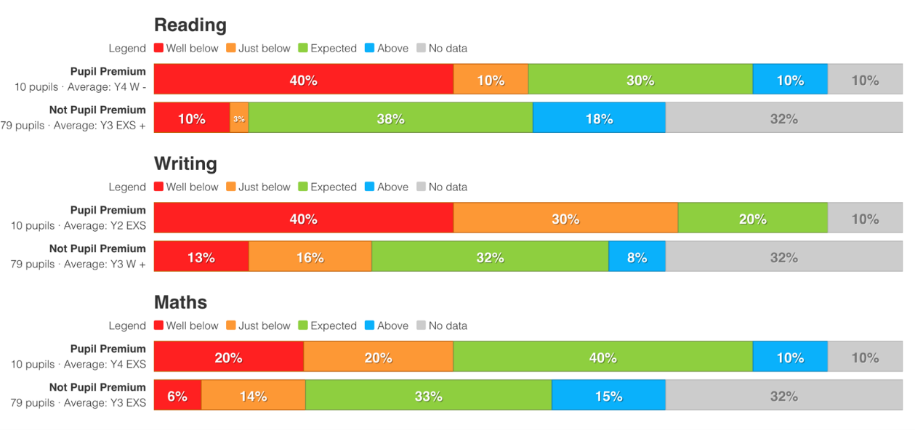
Attainment

Progress
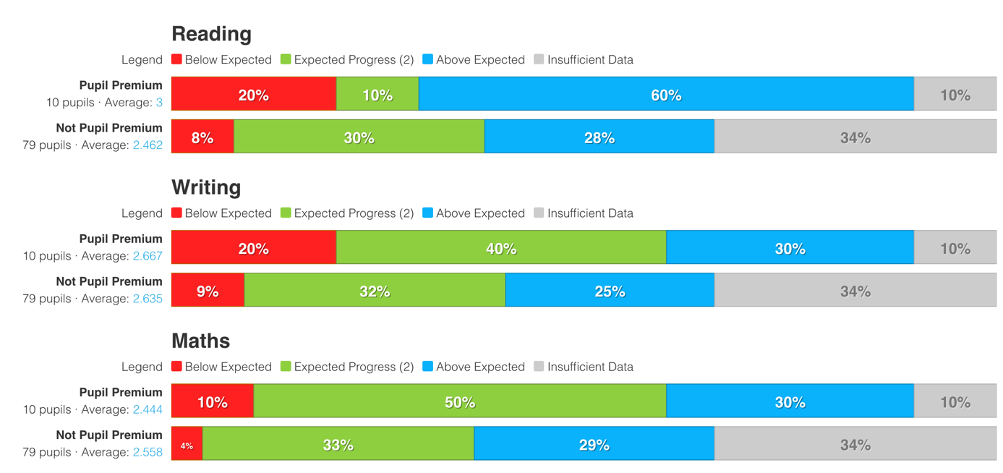
70% children in receipt of PP made expected or above expected progress in reading with one child making 5 steps progress and one child making 6 steps progress
70 children in receipt of PP made expected or above expected progress in writing with one child making 5 steps progress and one child making 6 steps progress
80% of children in receipt of PP made expected or above expected progress in maths with one child making 6 steps of progress in the year.
The art and music curriculums have been developed alongside the wider curriculum. Staff knowledge was increased thanks to the training and resourcing, leading to more effective teaching in all areas of the curriculum.
Clear progress was made in EYFS thanks to the increased quality of lesson delivery due to increased professional dialogue between staff in the EYFS unit.
Wider strategies enabled families to access a range of opportunities to develop pupil confidence and increase their access to the curriculum.
Home and school links have increased due to greater communication targeted directly at PP families including an end of year questionnaire and PP families having a better understanding of what the funding can be used for. This has increased parental engagement and developed a more positive relationship with school.
Through consultation with parents, it has been identified that the areas that parents of PP children feel their children need the most is support with covering the cost of extra-curricular activities including school trips.

